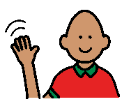

When I see someone I know…


When I see someone that I know it’s nice to say ‘Hi’ and their name. This makes people feel happy.
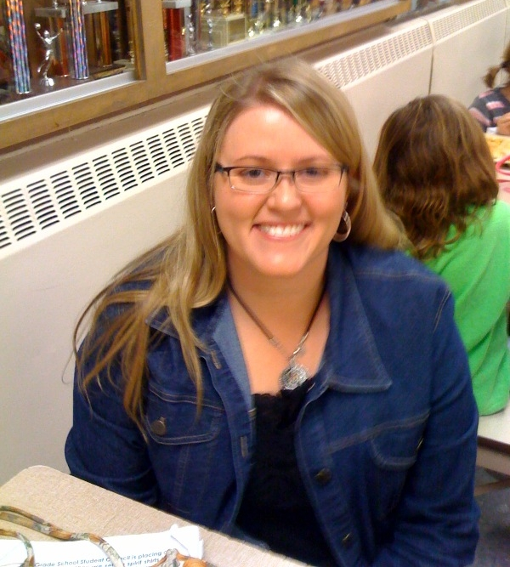

When I see my helper, Mrs. DeBolt, I should say ‘Hi Mrs. DeBolt.’


When I see the principal, Mr Caldwell, I should say ‘Hi Mr Caldwell.’
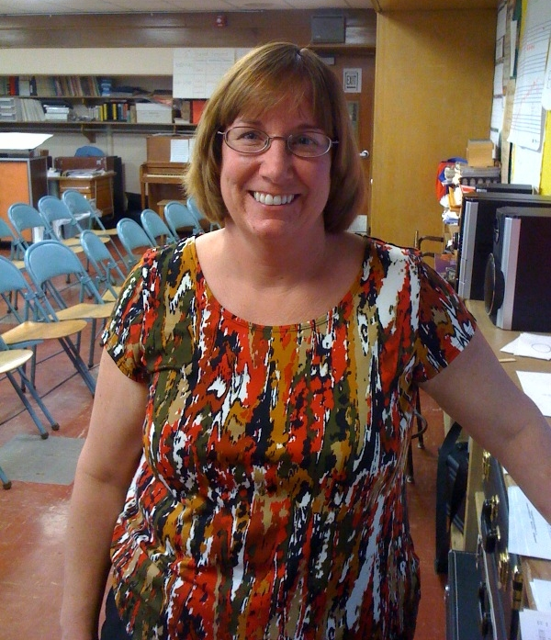

When I see the music teacher, Mrs. Hammende, I should say ‘Hi Mrs. Hammende.’



When I see my speech teacher, Miss Schuldt, I should say ‘Hi Miss Schuldt.’


It is good to say ‘Hi’ to people.

