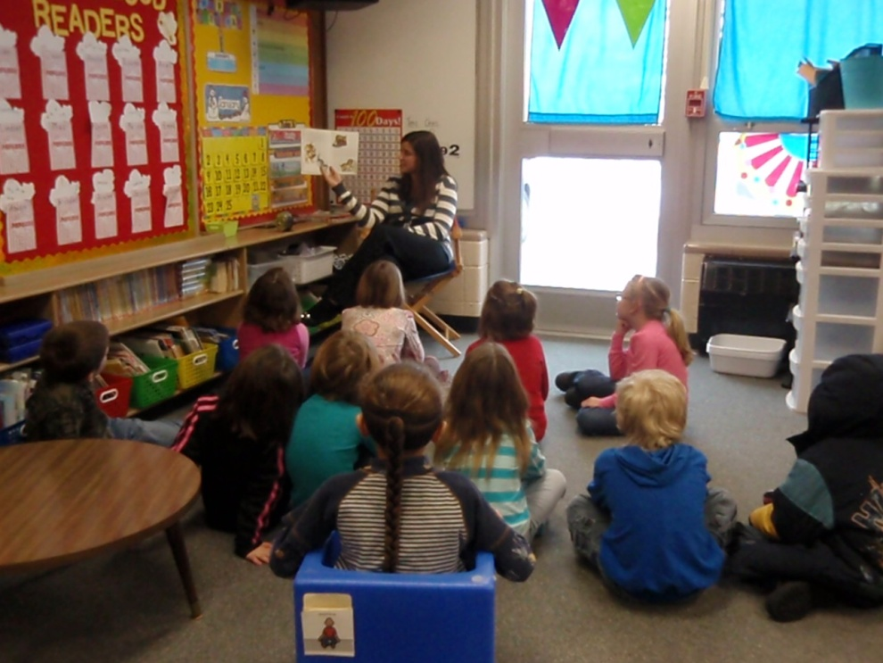
Carpet Time
Mrs. Schroeder has Carpet Time every morning. It is important to unpack my backpack and finish Calendar Time quickly so I can go to Carpet Time.

During Carpet Time, I should sit quietly in my seat with my hands folded in my lap and I should listen to Mrs. Schroeder.
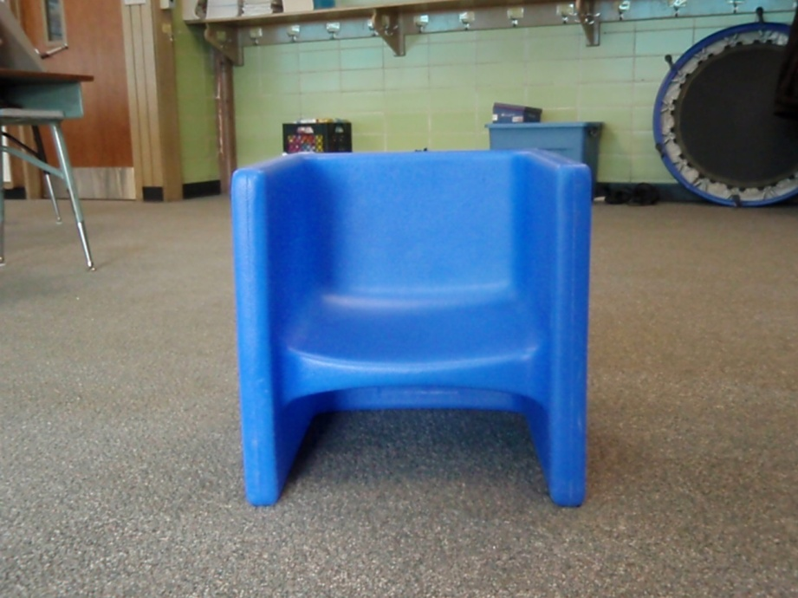
It is good to watch the Calendar Helper do their job. Soon it will
be my turn to help Mrs. Schroeder.

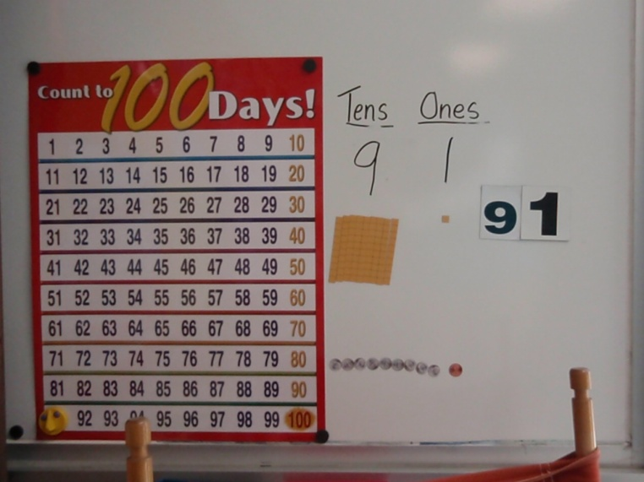
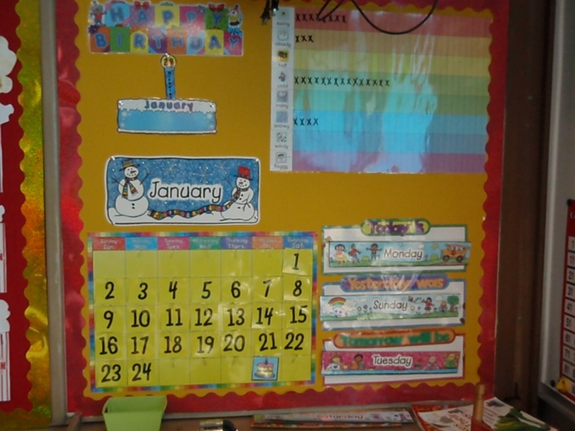
When Mrs. Schroeder reads a story it is important to follow directions and sit quietly with my hands in my lap. Listening to the story is fun.
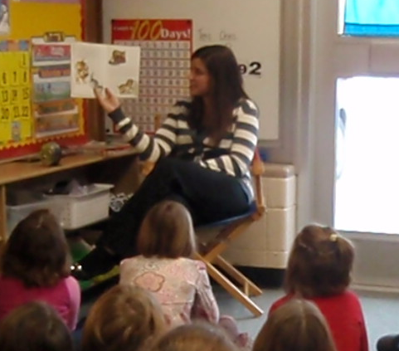
If I follow directions at Carpet Time I will get to take a break
after Carpet Time.


